**Research Article**

**Long-term Ac-227 Dose of Accelerator Generated Ac-225 in Mice**

Andrew L. Lakes 1, Dahlia D. An 1, Julian A. Rees 1, Rebecca J. Abergel 1,2

1 Chemical Sciences Division, Lawrence Berkeley National Laboratory, Berkeley, CA 94720

3 Department of Nuclear Engineering, University of California Berkeley, Berkeley, CA 94709

**Corresponding author:** Rebecca J. Abergel. [rjabergel@lbl.gov](mailto:rjabergel@lbl.gov).

**First author:** Andrew L. Lakes. [andrewllakes@gmail.com](mailto:andrewllakes@gmail.com).

**Words:** xxxx. **Figures**: xxxx. **Tables**: xxxx. **References:** xxxx

**Financial:** This work was supported by

**Running title:**

**Keywords:**

**Abstract:**

Production something

With three different Ac-225 constructs, we model static-distribution future dose rate for Ac-227 contamination in Ac-225 doses in mice out to one Ac-227 half life, 21.77 years.

**INTRODUCTION**

1) Ac-225 isotope production

2) Ac-227 decay properties compared to Ac-225Ac-225 decays rapidly after the initial 9.9 day alpha decay into Fr-221, with a 45.5 minute pause for the half-life of Bi-213.

After this pause, there remains only 1 alpha decay (Po-213), accounting for 30% of the total alpha energy released. The Ac-227 decay chain begins with a low energy beta decay over a lengthy 7946 days, resulting in the therapeutically relevant Th-227.

The Th-227 alpha decays into Ra-223 after 18 days. After the 11.43 day alpha decay from Ra-223 intoRn-219, the remaining daughters decay with rapidity other than the 36 minute half-life of Pb-211, resulting in a final tally of 5 alpha and 3 beta decays. After Pb-211 pause, there remains only 1 alpha decay (Bi-211), accounting for 20% of the total energy released. The total energy released during the Ac-227 decay chain is approximately 20% greater than the Ac-225 chain.

3) study set up / why

Materials tested -> can cite tastuzumab-Ac-225 literature

3) Long term dose effect of Ac-227

**MATERIALS AND METHODS**

**Materials**

3,4,3-LI(1,2-HOPO), referred to as HOPO, was XXXXXpurchased or synthesized?XXXXXXX. IgG1 antibody was purchased from Sigma-Aldrich. Trastuzumab was XXXdonated or purchased?XXXXXXX. 1,4,7,10-Tetraazacyclododecane-1,4,7-tris-acetic acid-10-maleimidoethylacetamide (DOTA-MMA) was purchased from Macrocyclics, Bradford reagent was purchased from Bio-rad, and tris(2-carboxyethyl)phosphine hydrochloride (TCEP HCl), L-glutathione reduced, and all other chemicals were purchased from Sigma-Aldrich.

**Activity counting**

All activity was counted with a Perkin-Elmer Tri-Carb 2910 TR. Dilutions of radiolabeled solution activity for injection were diluted with 10 mL of Ultima Gold LLT scintillation cocktail. For biodistribution, samples were ashed in a furnace, dissolved in nitric acid, and diluted into 10 mL Ultima Gold LLT scintillation cocktail.

**Radiolabeling**

*Caution: Lu-177 and Ac-225 are radioactive isotopes that may present serious health risks when incorporated. Experiments were performed in facilities specially designed for the safe-handling of radioactive materials at the Lawrence Berkeley National Laboratory (LBNL).*

For DOTA and HOPO radiolabeling sans antibody, a dry heating block was used to heat ligands to 60 ºC for 2 hours in pH 7.4 10 mM phosphate buffered saline (PBS) at 200:1 excess Ligand:Metal. For antibodies-DOTA conjugates, a dry heating block was warmed to 45 ºC and antibody-DOTA conjugates (cysteine sites) were pre-incubated for 5 minutes, dissolved in 0.1M pH 5.4 ammonium acetate. Radionuclide in 0.05N HCl was added at 200x excess Ligand:Metal for 2 hours. Starting activity was based on an aliquot of the stock solution at equilibrium upon radiolabeling. These radiolabeled solutions were washed and buffer exchanged (10x volume 5 times) into PBS of pH 7.4, and aliquots of filtrate and retentate were taken for final activity and yield verification.

**Animal Handling**

All procedures and protocols used in the described *in vivo* studies were reviewed and approved by the LBNL Institutional Animal Care and Use Committee (IACUC) and were performed in AAALAC accredited facilities.

**Animal Injection**

Contamination is achieved by intravenous injection in a warmed lateral tail vein of the challenge chelated isotope. Animals are housed in metabolism cages, per randomization group (n = 3). Urine and fecal pellets are collected daily until necropsy. Blood, liver, kidneys, spleen, heart, lungs, thymus, abdominal remainder tissue (ART), skeleton, and soft tissue remainder samples collected at scheduled necropsy and processed for analysis. Counting is done on a gamma counter and on an alpha/beta LSC counter. Samples are counted promptly after processing and repeatedly over 100 days to allow for equilibration of Ac-227 daughter products.

**Biodistribution**

Biodistribution results are reported as percent recovered dose per mass (%RD/g) as excreta was collected alongside the organs and tissues. xxxxxxxxxxxxxxxxxx

**Dose Modeling**

Utilizing the kinetic dose results, we created an estimated future dose for DOTA-Ac, Trastuzumab-DOTA-Ac, and HOPO-Ac control (see supplemental) accelerator-generated actinium constructs. The input dose bolus was 200 nCi for Ac-225 and 1 nCi for Ac-227 (0.5% Ac-227 contamination), and assumed to be pure actinium without daughters (all activity is only actinium at time = 0 of the injection). Dose modeling was performed across two regimes: 1) interpolation within the actual recorded data set (0-10 days), and 2) extrapolation of future dose assuming no further change in final time point. Between real recorded time point values of 1 hr, 4 hr, 24 hr, 4 days, 6 days (and 10 days for Trastuzumab-DOTA only), small step changes were added for interpolation. Numerically solving the standard Bateman ordinary differential equations produced an activity per time correlation. Next, using the energy output for each decay along the daughter series’, a moving average of power per count of activity (MeV/minute / CPM) for each time step was found, to get MeV/count. 100% efficiency of counting was assumed per decay. For time points within the real recorded time points, a monotonic cubic spline was used to gather activities, where activity past the real data assumes no change in biodistribution, and only decay occurs (see **Figure Sxxx**). Power per mass (MeV/(g*day)) was found per time step based on organ masses, and was numerically integrated to convert to energy per mass for conversion into units of Grey. Unequal variance standard deviation was also modeled via cubic spline interpolation and numerical integration for real data points with error propagation, and 95% confidence intervals were determined via assuming n=5 for each future time point beyond the real data of n=5. To determine the time of unity for Ac-227/Ac-225 ratios for dose per day, an exponential fit was used, and for cumulative dose a linear fit was used. Each organ/tissue point of unity was determined from a cubic spline interpretation, along with the error.

**RESULTS --------🡪 update figure letters and numbers!**

After injection of 2 nCi/g of Ac-225 construct with up to 0.5% Ac-227 contaminant to either 1) female Swiss-Webster mice with DOTA-Ac or HOPO-Ac control, or 2) female NOD SCID PDX mice with Trastuzumab-DOTA-Ac, biodistribution of Ac-225 and Ac-227 was investigated over several time points. DOTA was used as the ligand for actinium due to its *in vivo* stability and commercial availability as a bifunctional chelator (cite Robertsom curr radiopharm 2015 - Development of 225Ac Radiopharmaceuticals: TRIUMF Perspectives and Experiences). Biodistribution was compared via recovered dose per gram (RD/g) or localization ratio (LR) of Ac-225/Ac-227 RD/g values to determine any distribution effects.

**Biodistribution**

*Recovered Dose per Mass*

DOTA biodistribution in healthy mice was typical with activity locating heavily in the kidneys initially compared to other organs, and rapidly dropping activity across all collected tissues due to renal clearance (**Figure 2A**). Ac-227 biodistribution, however, indicated lingering carcass content over 6 days, but at low content (**Figure 2B**). In NOD SCID HER2-positive patient derived xenograft mice treated with targeted Trastuzumab-DOTA-Ac, RD/g biodistribution was also typical, where blood circulation content decreased over time more slowly than DOTA-Ac due to extended circulatory half-life antibodies provide, and with increasing spleen uptake as the largest %RD/g (likely due to immune opsonization), followed by liver and tumor uptake (**Figure 2C/D**). As a control for a predominantly hepatic-based clearing system, HOPO-Ac was also tested. As anticipated in native mice, liver uptake was high for both Ac-225 and Ac-227, with lower biodistribution to other organs throughout 6 days after injection (**Figure S3**).

*Isotopic Localization Ratio*

Interestingly, even though both Ac-225 and Ac-227 samples were counted at secular equilibrium using the same method (liquid scintillation counting of ashed tissue samples, Ac-227 equilibrium starts at roughly 100 days, Ac-225 after roughly 13 hours), Ac-225 appears to localize differently to Ac-227 depending on the initial parent construct. LR data in **Figure 3** are based upon ratios from **Figure 2** biodistribution recovery results. Across the board for all tissues, the LR of DOTA-Ac (**Figure 2A**) shows more rapid clearance from the body of Ac-225 compared to Ac-227, with LR below 1. With Trastuzumab-DOTA-Ac (**Figure 2B**), however, the Ac-227 clears faster at longer time points for the spleen. As the blood LR increased for Ac-225, so did spleen, but with only a single significant difference at the final 10-day time point for the spleen LR (n=5, mean = 2.94 ± 1.43 SD, one-tailed P-value = 0.02 vs. unity). The 10 day time point for Trastuzumab-DOTA-Ac LR is beyond the scale due to extremely low activity in the Ac-227 biodistribution sample, and standard deviation error bars cross the abscissa indicating no significance. HOPO-Ac LR for the heart, lungs, kidneys, liver, and carcass tended to be at or greater than 1 (**Figure S4**). LR also trended a decrease from above unity in earlier time points to at or below unity in later time points for all organs except the spleen and ART. For the organ with greatest localized uptake with both isotopes, the liver, the LR at the final time point at 6 days was not statistically significant from unity.

**Dose Modeling**

After dose interpolation and extrapolation of each organ’s RD/g assuming an equal 200 nCi Ac-225 and 1 nCi Ac-227 (0.5%), output measurements of dose vs time, dose ratio (Ac-227/Ac-225) vs time, and dose/day vs time were calculated.

*DOTA-Ac*

DOTA-Ac had the greatest cumulative Ac-225 dose to the kidneys, with a dose of 0.0167 Gy (95% CI 0.0150-0.0183 Gy) at 100 days (**Figure 2E**), where Ac-227 only showed roughly 20% the dose at 0.00331 Gy (95% CI 0.00315-0.00347 Gy) (**Figure 2E**). However, the estimated Ac-227 cumulative dose continued to increase to 0.311 Gy (95% CI 0.296-0.326 Gy) after 7946 days (**Figure 2E**) for a Ac-227/Ac-225 dose ratio of roughly 20 times at 7946 days (**Figure 2F**). Compared to the kidneys, the carcass for Ac-227 showed roughly 2x higher cumulative dose. The dose per day for DOTA-Ac-225 in the kidneys showed a maximum at the initial time point of 1 hour, with 3.02E-3 Gy/day (95% CI 2.95E-3 - 3.09E-3 Gy/day) (**Figure 3C**), with a DOTA-Ac-227 maximum at 200 days with only 5.35E-5 Gy/day (95% CI 5.09E-5 – 5.60E-5 Gy/day) (**Figure 3D**), and the DOTA-Ac-227 carcass showing roughly twice the dose per day.

*Trastuzumab-DOTA-Ac*

Trastuzumab-DOTA-Ac showed uptake primarily in the spleen, with a 125-day dose maximum of 20.4 Gy (95% CI 17.0-23.8 Gy) for Ac-225 (**Figure 2G**), and after 7946 days Ac-227 showed a slowing cumulative dose of 33.7 Gy (95% CI 29.6-37.7 Gy) (**Figure 2H**) for a dose ratio of Ac-227:Ac-225 of roughly 1-5:1 for all samples but blood (**Figure 2I**). The dose per day, however, showed a lower peak dose rate for the spleen of 0.88 Gy/day (95% CI 0.71-1.1 Gy/day) for Trastuzumab-DOTA-Ac-225 at 7 days (**Figure 3E**), and at 200 days 0.058 Gy/day (95% CI 0.051-0.065 Gy/day) for Trastuzumab-DOTA-Ac-227 (**Figure 3F**). Cumulative dose to the kidneys was found to be low for both Ac-225 and Ac-227, at 0.54 Gy (95% CI 0.49-0.58 Gy) and 1.42 (95% CI 1.35-1.49) respectively, as was the kidney dose per day, with Ac-225 at 3 mGy/day (95% CI 2.9-3.1 mGy/day) and Ac-227 at 54 µGy/day (95% CI 51-56 µGy/day).

**DISCUSSION**

This study was set up as an initial estimate of the long term toxicity for trace Ac-227 present in radiopharmaceuticals utilizing accelerator-produced Ac-225. Mice in each group were given a target dose of 2 nCi/g Ac-225 with up to 0.5% Ac-227 contaminant. At the final time point of biodistribution sampling, it was assumed that distribution was now static in time, disallowing future distribution, with only decay occurring. Also, all samples were left to sit to secular equilibrium for Ac-225 and Ac-227 counting (see **Figure 1**). Estimates of future cumulative and dose per day were based on a real injection into mice of 8 nCi/g Ac-225 constructs (40% maximum tolerated dose (MTD) of antibody-DOTA-Ac-225 conjugates 1 (Lakes 2019 Ac-225 Lu-177). Considering Lakes2019 MTD is based on acute effects of Ac-225 (no Ac-227) out to 35 days, it does not speak for long term dose effects of Ac-227, and is taken only as an acute guideline.

In general, for radiotherapies, as well as targeted alpha therapies, the dose limiting factor tends to be renal toxicity 2–4. In humans, short half-life radiotherapies typically present a delayed toxicity well beyond the decay of the radioisotopes, and is known to occur between months and years after radiation treatment 5,6. Based upon the literature, we can create ballpark estimates to determine for both Ac-225 and Ac-227 if ,1) is the cumulative dose to vital organs at or below the acute threshold, and if not, 2) are the dose-per-day values reasonable due to cumulative dose occurring over an extended period.

Considering small molecule therapies with Ac-225, in human patients off-trial using experimental Ac-225-PSMA-617 peptide conjugate, the maximum cumulative dose to the kidneys was tolerated at 16.8 SvRBE5 (3.36 Gy) from 3x fractionated ~7.4 MBq doses (200 nCi each, 5.6 Gy/µCi) 5,7, with an approximate 27 SvRBE5 as the MTD (5.4 Gy) 8. For protein based Ac-225 radioimmunoconjugates, clinicaltrials.org shows six recruiting/active/completed phase I studies in the United States, however dose estimate data could not be found. Nonetheless for an estimate, in mice, there have been a few studies reporting a variety of ranges for radioimmunoconjugate dosimetry. In one study with Ac-225-HuM195 antibody conjugates, an upper-end kidney dose of 27.6 Gy (138 SvRBE5) was tolerated with the additional administration of a kidney protectant from 350 nCi administration to SCID mice, giving (79 Gy/µCi) 9. In another with a lower end range, Ac-225-DOTA-anti-PD-L1-BC conjugates delivered to *neu*-N mice at a 15 kBq dose (405 nCi) created absorbed doses of 9.2 Gy kidneys (22.7 Gy/uCi, 46 SvRBE5), 11.1 Gy liver (27.4 Gy/µCi, 55.5 SvRBE5), and 2 Gy spleen (4.9 Gy/µCi, 10 SvRBE5) 10. These values are, as is typical, markedly higher for mice than for humans.

In our study, Trastuzumab-DOTA-Ac conjugates administered to NOD SCID mice showed the anticipated biodistribution, considering antibodies are often distributed to immune-functioning organs such as the spleen, liver, and targeted tumor 11 (**Figure 2**). Also typical was DOTA-Ac complex biodistribution in healthy Swiss-Webster mice, where DOTA displayed rapid renal clearance 4 (**Figure 2**). While there is higher kidney distribution than other organs, the rapid renal clearance resulted in over an order of magnitude lower kidney dose (**Figure 4**) due to the long circulatory half-life of Ac-225 and Ac-227 antibody conjugates. Contrasting to DOTA, our HOPO control group typically shows primarily hepatic clearance 12, and accordingly the liver showed the largest portions of distribution (**Figure S3**). Comparing our cumulative mouse dose modeling data to the literature values, the cumulative Ac-225 dose maximum to the liver after 100 and 125 days for DOTA-Ac-227 and Trastuzumab-DOTA-Ac-225 respectively are significantly lower than the clinical threshold of 3.36 Gy found in the Ac-225-PSMA-617 trial (see **Table 1**).

While acute doses are typical for radiotherapies, long term dose effects from alpha radiation is less studied. Long term doses often involve reduction in immune function due to chronic bone marrow function decay, as over time there tends to be a depletion of the stem cell compartments 6,13. Thus, Ac-227 effects from this study may be compared to what literature is available, often involving gamma irradiation. In an estimate to correlate to external beam studies, where 100% of injected Ac-227 was retained in the mouse regardless of carrier (4% RD/g total body for a 25 g mouse at 10 days), after 7946 days, Ac-227 would show 2.25 Gy cumulative total body dose, with a peak of 388 µGy/day, or 142 mGy/year after 200 days, lessening to 79 mGy/year after 7946 days. The RBE for whole body alpha is generally considered to be 10:1 alpha:gamma, and so that would give 1.4 SvRBE10/year, which is over the 0.4 Gy/year threshold for depression of hematopoiesis 14, but much lower than the lethal bone marrow dose maximum of >4.5 Gy/year However, looking at the actual carcass (ashed remainder of animal, including bones) values for Trastuzumab-DOTA-Ac-227 show 197 uGy/day maximum (95% CI 194-200 uGy/day) which equates to 72 mGy/year on average or 0.36 SvRBE5/year for bones which is just below the 0.4 Gy/year threshold.

Considering the spleen is not as vital an organ as the kidneys or liver, spleen chronic toxicity has been shown to appear in rats and mice exposed to 0.01–0.5 Gy/day of gamma radiation, which calculates out to 0.05-2.5 SvRBE5/day alpha 6. While the Trastuzumab-DOTA-Ac-225 rate per day reaches beyond this level, it is only for a short term, but Ac-227 does get within the toxicity range with an equivalence mean of 0.29 SvRBE5/day.

It is important to keep in mind that this study is limited to counting only activity due to direct parent-daughter activity after tissue resection. This should result in undercounting effects due to daughter re-distribution to organs after recoil effects 15. Daughter isotope re-distribution has been observed in other studies, and redistribution of Bi-213 has been shown to cause dose-limiting renal toxicity in Ac-225 therapies 16. As an example, modeling the fraction of activity produced from decays prior to the first alpha decay in each Ac-225 and Ac-227 decay chains produces **Figure S8**, and exemplifies how if the first alpha decay were to release the metal from the ligand carrier due to recoil, isotopic daughter distribution variance would also occur. Within the first few days of administration of pure Ac-225 and pure Ac-227 into a ligand, Ac-227 and Th-227 daughter would remain largely intact, whereas Ac-225 would rapidly reach secular equilibrium, with more activity coming from freed daughters than parent. This effect may be measured, if desired, via gamma counting, but it was not deemed necessary considering we were more interested in long-term dose effects from Ac-227.

Nonetheless, we did observe interesting localization ratio (LR) effects of Ac-225/Ac-227. As can be seen in the LR for all three tested constructs, while LR is calculated via %RD/g ratios, LR is not directly dependent upon the absolute %RD/g between constructs. For instance, while DOTA-Ac shows much lower activity than Trastuzumab-DOTA-Ac and the DOTA-Ac LR is below 1 and Trastuzumab-DOTA-Ac at or greater than 1, the HOPO-Ac control has several tissues with sub-10 %RD/g that are greater than 1 (blood, heart, lungs). Therefore, this is likely due to a factor other than activity counting conditions that is creating isotopic localization, post-equilibrium. The trend these LR data do seem to follow is the rate of excretion from the animal. DOTA-Ac is the quickest to clear, HOPO-Ac the second quickest, and Trastuzumab-DOTA-Ac is the slowest. Since %RD/G is not based on the initial injected amount but the amount recovered in total at the final time point, this is also not simply due to rapid decay of Ac-225 vs Ac-227. It is possible that changes in LR may be due to biomolecular actinium scavenging of constructs directly, pre-decay. However, that would require a difference in chemical potential between isotopes in the same constructs and/or scavenging molecules. While this occurs naturally in numerous systems 17–19, most notably δ13C differential sequestration in ecology , where kinetic fractionation occurs due to the added neutron mass, the added mass in Ac-227/Ac-225 (+0.88%) is a much smaller fraction than with C-13/C-12 (+8.3%). If this is the case, then perhaps the DOTA-Ac complexes are more easily scavenged than Trastuzumab-DOTA-Ac due to less steric hindrance, and Ac-225 more easily scavenged compared to Ac-227 and cleared more rapidly from the body. Otherwise, there are some cases of mass-independent fractionation due to differences in nuclear magnetic moment in heavier elements, such as in paramagnetic iron isotopes in magnetotactic bacteria 20. Search for differences could be tested through further experimentation in mice with variations of Ac-225 / Ac-227 dose in a weak ligand, such as citrate, to promote biomolecular scavenging.

**CONCLUSIONS**

Considering the limitations of this study only collecting raw data out to 6-10 days, the dose extrapolation seems very promising for utilization of accelerator generated Ac-225 with longer and large scale studies. While Ac-227 constructs do seem to create a measurable absorbed dose over extended periods of time, the cumulative dose does not become significant for years, and may still be beneficial for late-stage patients. The observation of different isotopic localization of Ac-225 vs Ac-227 is an interesting and unexpected outcome, and will be investigated further.

**REFERENCES**

1. McDevitt MR, Ma D, Lai L, et al. Tumor Therapy with Targeted Atomic Nanogenerators. *Science (80- )*. 2001;294(5546):1537-1540. doi:10.1126/science.1064126

2. Vegt E, de Jong M, Wetzels JFM, et al. Renal Toxicity of Radiolabeled Peptides and Antibody Fragments: Mechanisms, Impact on Radionuclide Therapy, and Strategies for Prevention. *J Nucl Med*. 2010. doi:10.2967/jnumed.110.075101

3. Podoll AS, Amsbaugh MJ. Radiation-associated Kidney Injury. In: *Renal Disease in Cancer Patients*. ; 2013. doi:10.1016/B978-0-12-415948-8.00007-6

4. A. Scheinberg D, R. McDevitt M. Actinium-225 in Targeted Alpha-Particle Therapeutic Applications. *Curr Radiopharm*. 2012. doi:10.2174/1874471011104040306

5. Kratochwil C, Bruchertseifer F, Rathke H, et al. Targeted α-Therapy of Metastatic Castration-Resistant Prostate Cancer with 225 Ac-PSMA-617: Dosimetry Estimate and Empiric Dose Finding. *J Nucl Med*. 2017;58(10):1624-1631. doi:10.2967/jnumed.117.191395

6. Clement CH, Stewart FA, Akleyev A V., et al. ICRP publication 118: ICRP Statement on Tissue Reactions and Early and Late Effects of Radiation in Normal Tissues and Organs Ã¢â‚¬â€ Threshold Doses for Tissue Reactions in a Radiation Protection Context. *Ann ICRP*. 2012;41(1-2):1-322. doi:10.1016/j.icrp.2012.02.001

7. Lengana T, Mahapane J, Lawal I, et al. 225Ac-PSMA-617 in chemotherapy-naive patients with advanced prostate cancer: a pilot study. *Eur J Nucl Med Mol Imaging*. 2018;46(1):129-138. doi:10.1007/s00259-018-4167-0

8. Kratochwil C, Schmidt K, Afshar-Oromieh A, et al. Targeted alpha therapy of mCRPC: Dosimetry estimate of 213Bismuth-PSMA-617. *Eur J Nucl Med Mol Imaging*. 2018;45(1):31-37. doi:10.1007/s00259-017-3817-y

9. Jaggi JS, Seshan S V., McDevitt MR, Sgouros G, Hyjek E, Scheinberg DA. Mitigation of radiation nephropathy after internal α-particle irradiation of kidneys. *Int J Radiat Oncol Biol Phys*. 2006;64(5):1503-1512. doi:10.1016/j.ijrobp.2005.11.036

10. Nedrow JR, Josefsson A, Park S, et al. Pharmacokinetics, microscale distribution, and dosimetry of alpha-emitter-labeled anti-PD-L1 antibodies in an immune competent transgenic breast cancer model. *EJNMMI Res*. 2017;7. doi:10.1186/s13550-017-0303-2

11. Sharma SK, Chow A, Monette S, et al. Fc-mediated anomalous biodistribution of therapeutic antibodies in immunodeficient mouse models. *Cancer Res*. 2018;78(7):1820-1832. doi:10.1158/0008-5472.CAN-17-1958

12. Rees JA, Deblonde GJP, An DD, Ansoborlo C, Gauny SS, Abergel RJ. Evaluating the potential of chelation therapy to prevent and treat gadolinium deposition from MRI contrast agents. *Sci Rep*. 2018;8(1):2-10. doi:10.1038/s41598-018-22511-6

13. Fliedner TM, Graessle DH, Meineke V, Feinendegen LE. Hemopoietic response to low dose-rates of ionizing radiation shows stem cell tolerance and adaptation. *Dose-Response*. 2012. doi:10.2203/dose-response.12-014.Feinendegen

14. Higley K, Real A, Chambers D. Annals of the ICRP Annals of the ICRP. *Ann ICRP*. 2018;ICRP ref:

15. de Kruijff RM, Wolterbeek HT, Denkova AG. A critical review of alpha radionuclide therapy-how to deal with recoiling daughters? *Pharmaceuticals*. 2015. doi:10.3390/ph8020321

16. Jaggi JS, Kappel BJ, McDevitt MR, et al. Efforts to control the errant products of a targeted in vivo generator. *Cancer Res*. 2005;65(11):4888-4895. doi:10.1158/0008-5472.CAN-04-3096

17. Keenan SW, DeBruyn JM. Changes to vertebrate tissue stable isotope (δ15N) composition during decomposition. *Sci Rep*. 2019;9(1):9929. doi:10.1038/s41598-019-46368-5

18. Moynier F, Fujii T. Calcium isotope fractionation between aqueous compounds relevant to low-temperature geochemistry, biology and medicine. *Sci Rep*. 2017. doi:10.1038/srep44255

19. Moynier F, Fujii T. Theoretical isotopic fractionation of magnesium between chlorophylls. *Sci Rep*. 2017;7(1):1-6. doi:10.1038/s41598-017-07305-6

20. Louvat P, Busigny V, Guyot F, et al. Mass-dependent and -independent signature of Fe isotopes in magnetotactic bacteria. *Science (80- )*. 2016;352(6286):705-708. doi:10.1126/science.aad7632

21. U.S.NRC. *NRC Regulations 10 CFR Subpart C--Occupational Dose Limits--20.1201*. https://www.nrc.gov/reading-rm/doc-collections/cfr/part020/part020-1201.html.

**TABLES**

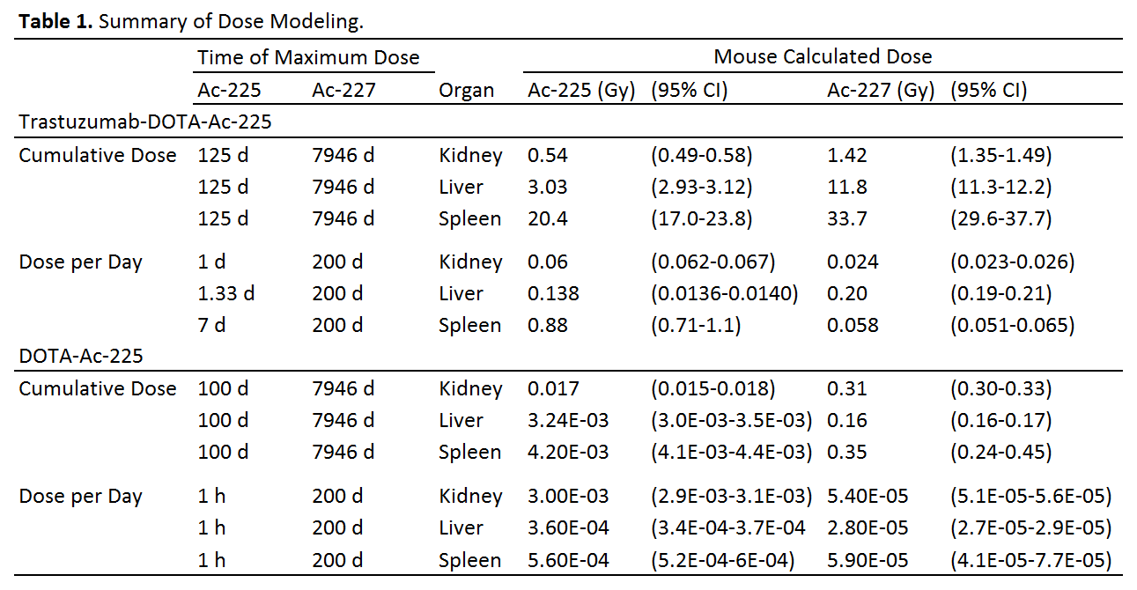

**FIGURES**

**A**

**B**

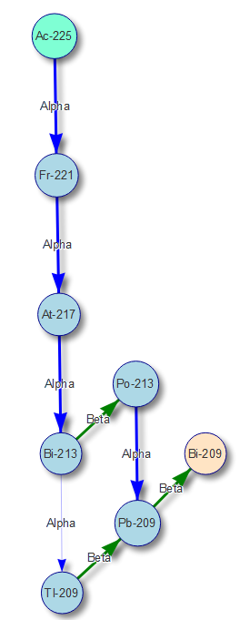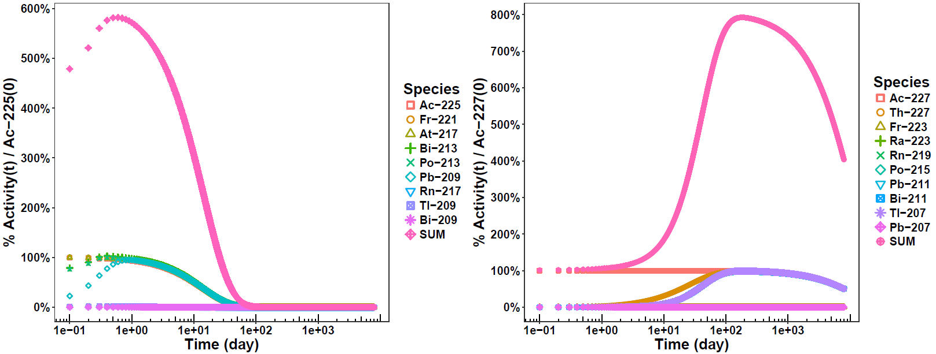

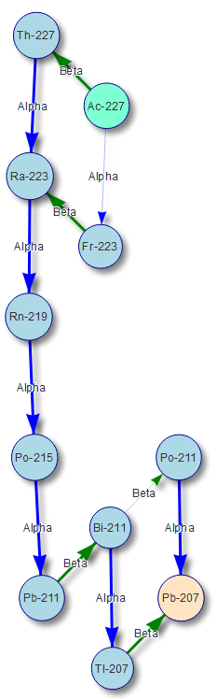 

**Figure 1.** Comparison of **A)** Ac-225 and **B)** Ac-227 decay. **Left:** Vertical placement is in relation to proton count. Parent is in teal, final daughter is in salmon, intermediate species with >0.1% incidence are blue. Line thickness indicates probability (thicker is greater probability). **Right:** Species activity in relation to pure actinium parent at t=0 [% Activity of Species(t) / Ac-22X(0)]. SUM is total of all species.

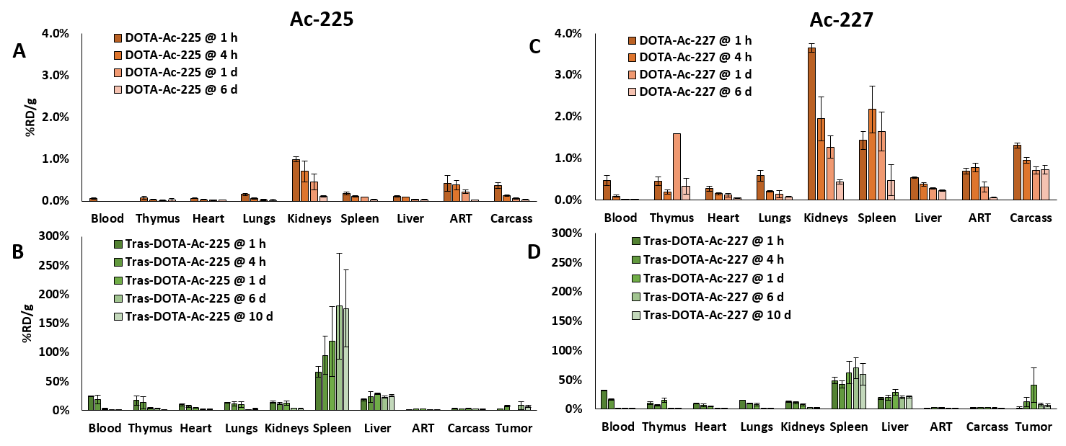

**Figure 2.** %Recovered dose per mass (%RD/g).

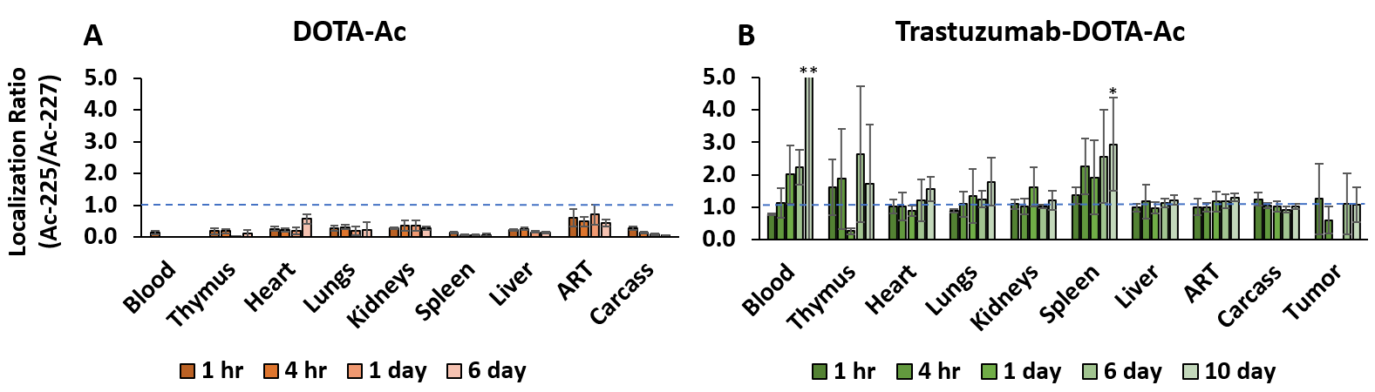

**Figure 3.** Localization ratio (recovered dose per mass of Ac-225/Ac-227). *P-value < 0.05. **value out-of-scale, mean 10.8 ± 19.0 SD.

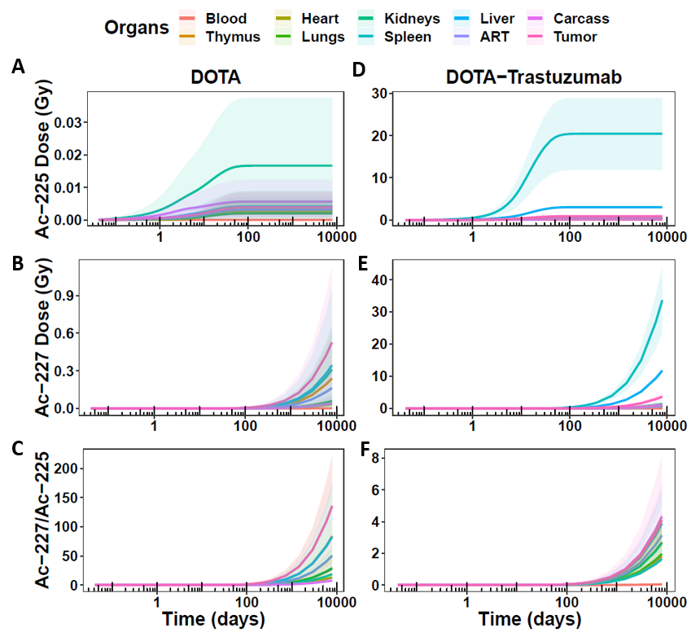

**Figure 4.** Cumulative dose over one Ac-227 half-life (7946 days).

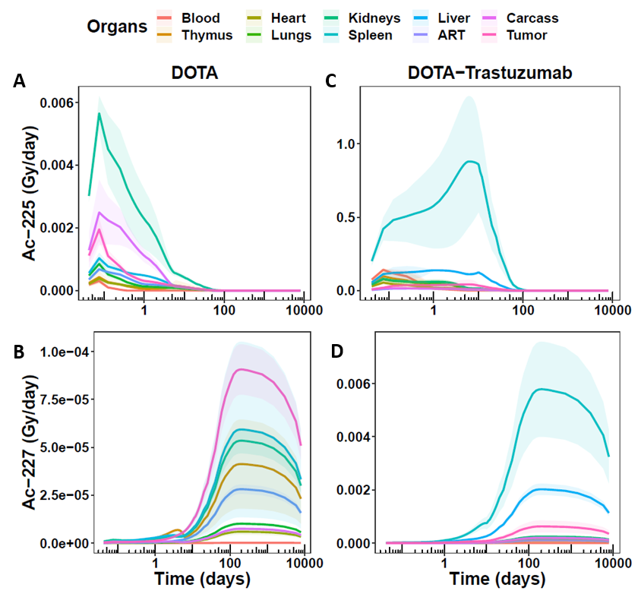

**Figure 5.** Dose per day over one Ac-227 half-life (7946 days).

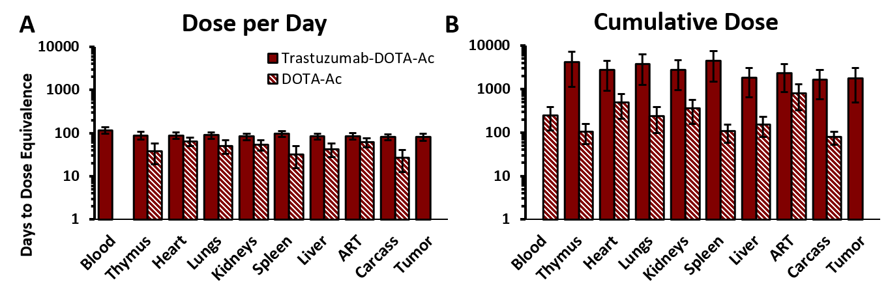

**Figure 6.** Number of days until dose equivalence between extrapolated Ac-227/Ac-225 dose ratios. In A), DOTA-Ac does not reach dose equivalence for the blood, and in B), Trastuzumab-DOTA-Ac does not reach dose equivalence for the blood.

**DISCLOSURE**

The authors have no disclosures.

**ACKNOWLEDGEMENTS**

This work was supported by xxxxxxxxxxxxxxxxxxxxxxxxxxxxxxxxxxxxxxxx

**SUPPLEMENTAL INFORMATION**

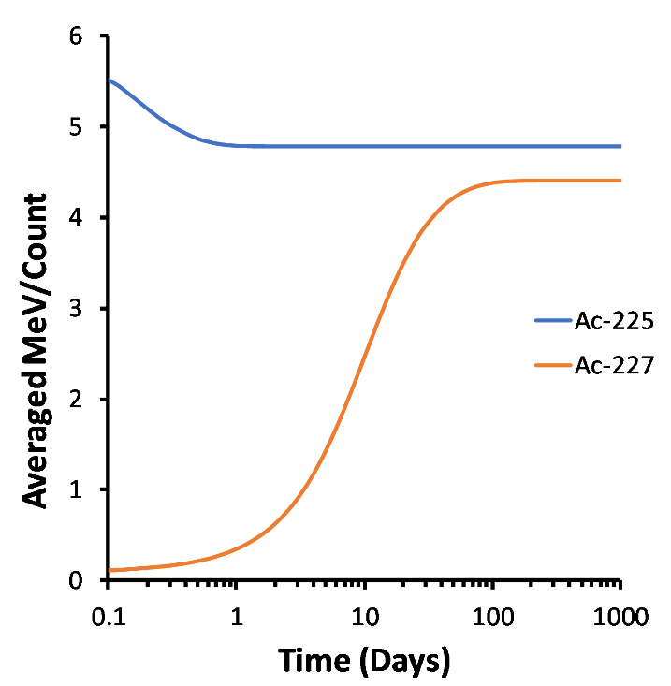

**Figure S1.** Starting with pure actinium species without daughters, equilibrium of average energy per destruction (counting both alpha *and* beta species) occurs rapidly within one day for Ac-225, and only after 100 days for Ac-227.

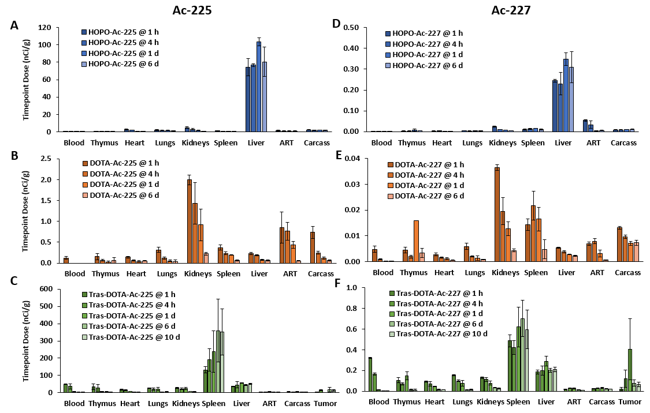

**Figure S2.** Dose biodistribution with exactly 200 nCi Ac-225 and 1 nCi Ac-227 per mouse, based on %RD/g plots in **Figure 2**.

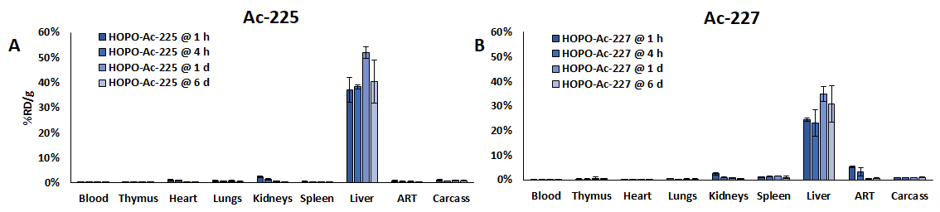

**Figure S3.** HOPO %RD/g. Considering the RD/g values from **Figure 2** are proportional to relative organ dose, HOPO showed greatest dose to the liver for both Ac-225 and Ac-227, with a cumulative Ac-225 mean dose of 4.26 Gy (95% CI 3.97-4.54 Gy) which remained steady after 125 days (A). HOPO-Ac-227 at 125 days showed an increasing mean dose of 0.323 Gy (95% CI 0.30-0.36 Gy), and after 7946 days, a mean of 22.4 Gy (95% CI 20.3-24.5 Gy) (B).

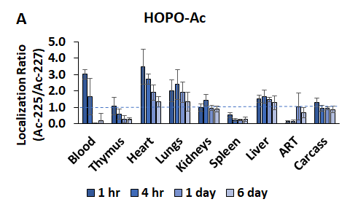

**Figure S4.** HOPO localization ratio.

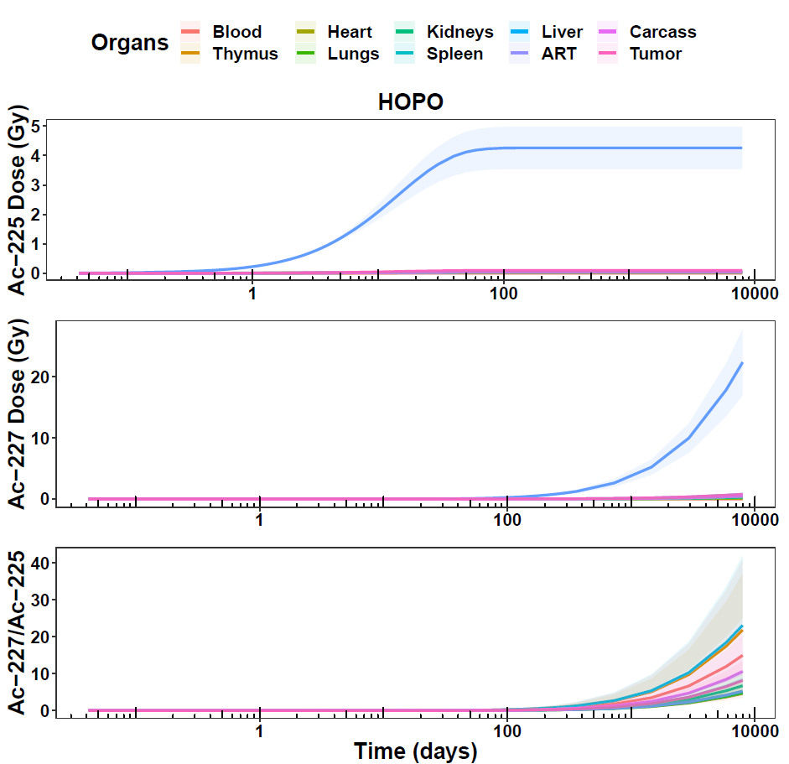

**A**

**B**

**C**

**Figure S5.** HOPO cumulative dose modeling. Due to the increasing values of Ac-227 cumulative dose, the dose ratios were initially small, and increased to a range of roughly 5-20 at 7946 days (C).

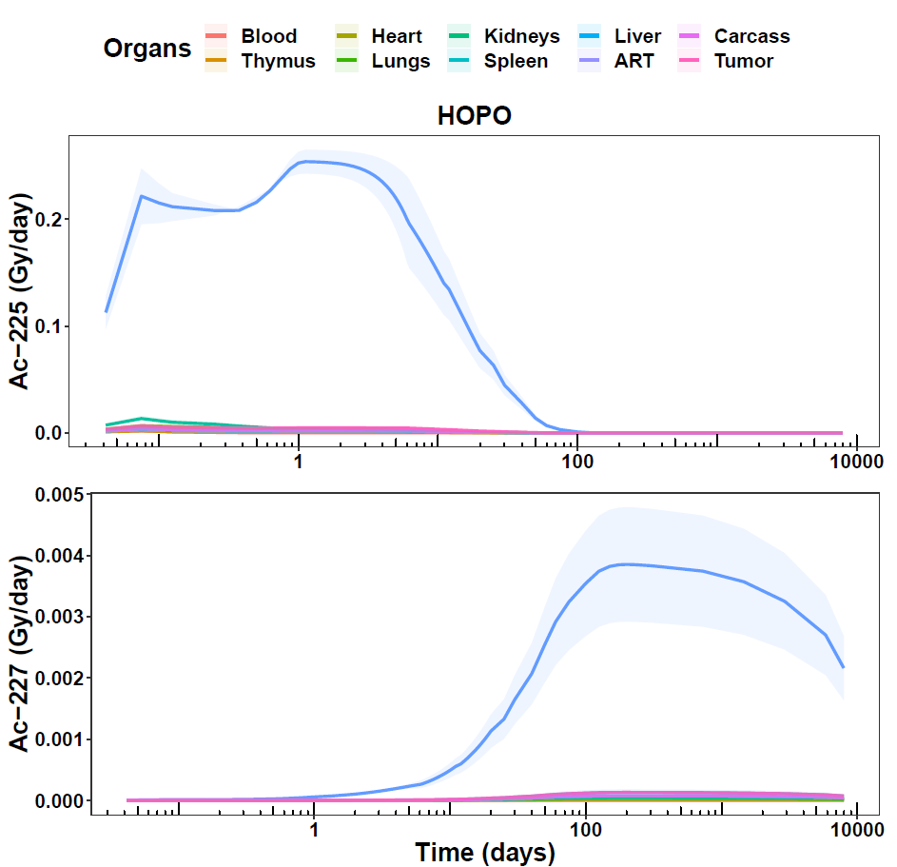

**A**

**B**

**Figure S6.** HOPO dose per day modeling. HOPO-Ac-225 showed a maximal mean of 0.254 Gy (95% CI 0.249-0.258) at 1.33 days (A) in the liver, whereas HOPO-Ac-227 showed a maximal mean of 0.039 Gy (95% CI 0.035-0.042) at 200 days in the liver and continued to decrease as Ac-227 decayed (B).

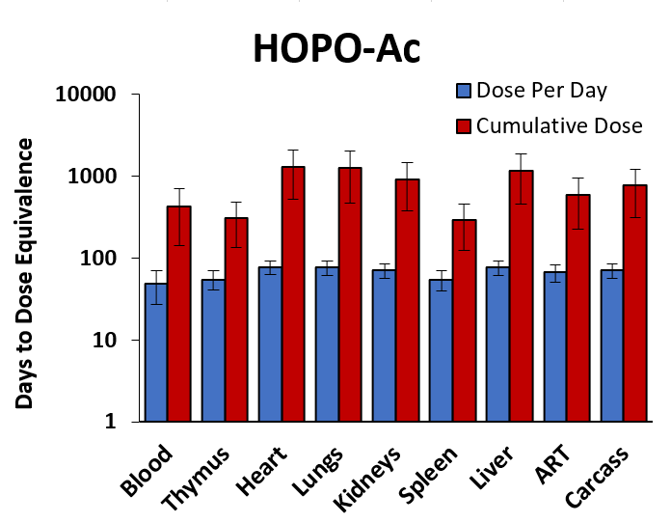

**Figure S7.** HOPO days until dose equivalence (Ac-227/Ac-225).

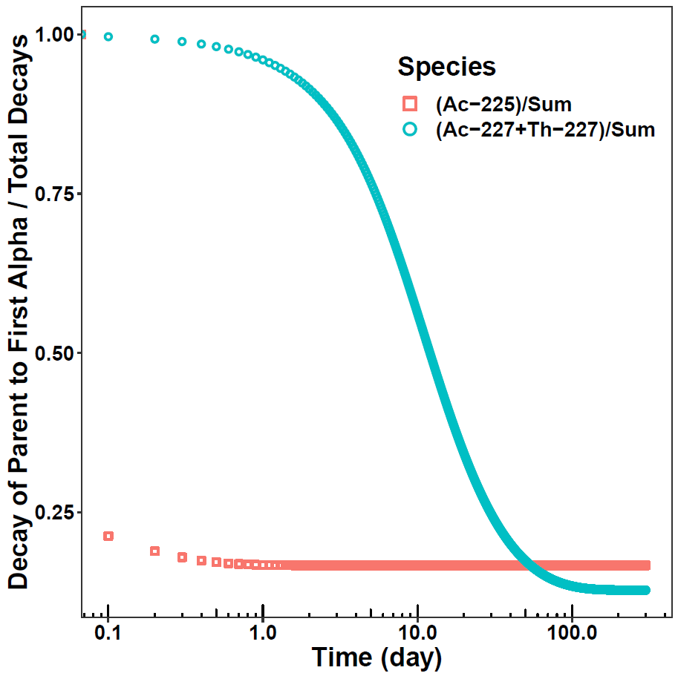

**Figure S8.** The ratio of